Sennheiser TeamConnect Ceiling 2 is now Compatible with Zoom

Wedemark, 23 June 2020 – Sennheiser is happy to announce that its TeamConnect Ceiling 2 microphone is now compatible with Zoom Video Communications, Inc.’s Zoom Meetings – as is the Bose ES1 Ceiling Audio Solution, an in-ceiling unified communications solution consisting of the Sennheiser TeamConnect Ceiling 2 microphone, the Bose ControlSpace EX-440C conferencing DSP, Bose EdgeMax EM180 in-ceiling loudspeaker and Bose PowerSpace P2600A amplifier. While ensuring perfect aesthetics for any conference room or seminar room, the system provides users with a seamless, high-quality audio experience. Zoom is a video communications solution that has become an indispensable resource for many businesses in light of the digital transformation of the workplace, and now more than ever in the wake of the COVID-19 pandemic which has forced many professionals to work remotely.

Sennheiser’s TeamConnect Ceiling 2 microphone and the ES1 Ceiling Audio Solution from Bose Professional and Sennheiser achieve Zoom compatibility
“Collaboration tools must enable people to connect seamlessly and with confidence,” says Charlie Jones, global business development manager for Sennheiser’s Business Communi-cation segment. “The Bose/Sennheiser solution does just that, and we are very excited to announce that this solution is now officially compatible with Zoom. The importance of video conferencing and webinar solutions has increased massively during the coronavirus crisis, and so has the significance of touchless microphone systems like TeamConnect Ceiling 2.”

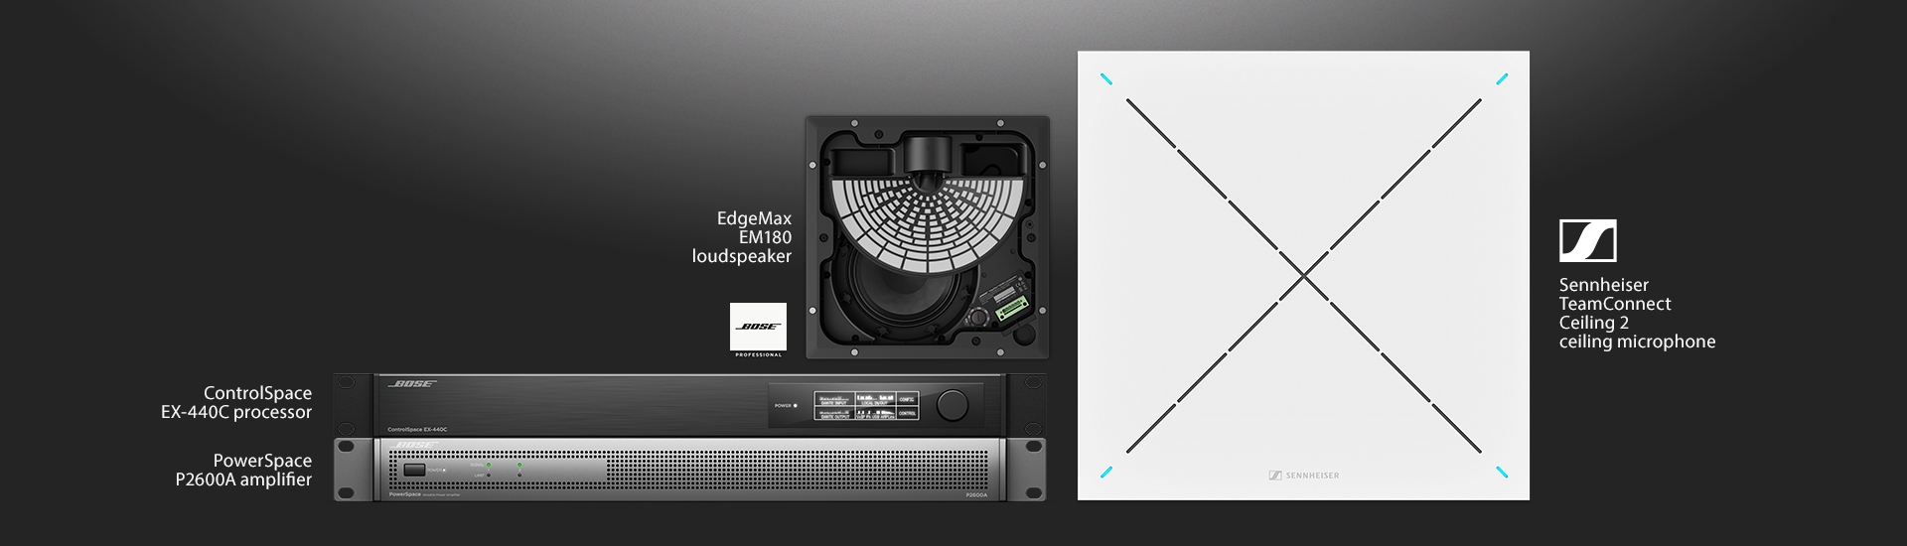
The Bose ES1 Ceiling Audio Solution consists of the Sennheiser TeamConnect Ceiling 2 microphone, Bose ControlSpace EX-440C conferencing DSP, Bose EdgeMax EM180 in-ceiling loudspeaker and Bose PowerSpace P2600A amplifier

“We’re extremely proud to be part of a reliable, in-ceiling audio solution that is Zoom compatible,” stated Martin Bodley, director and global head, Bose Work at Bose. “The Bose ES1 brings together a selection of innovative products that deliver the perfect combination of transparent technology to support how and where people work – so you can focus on what’s important.”

Sennheiser’s TeamConnect Ceiling 2 microphone uses adaptive beamforming to automatically and reliably pick up the person speaking in a conference room, no matter where he or she is located within the space. The microphone allows for freedom of movement, flexible use of conference rooms and outstanding audio quality.

In addition to business conferencing applications, the Sennheiser TeamConnect Ceiling 2 is increasingly employed in higher education environments, where it facilitates distance learning, especially with seminars which usually require a greater freedom of movement and feature several speakers. In addition, as hygiene continues to be top of mind, the TeamConnect Ceiling 2 enables touchless audio in classrooms to more easily maintain social distancing best practices while ensuring all students experience clear and discernable lectures.

The images accompanying this press release can be accessed at https://sennheiser-brandzone.com/c/181/bvbycKnZ.

About Sennheiser
Founded in 1945, Sennheiser is celebrating its 75th anniversary this year. Shaping the future of audio and creating unique sound experiences for customers – this aim unites Sennheiser employees and partners worldwide. The independent family company, which is managed in the third generation by Dr. Andreas Sennheiser and Daniel Sennheiser, is today one of the world’s leading manufacturers of headphones, loudspeakers, microphones and wireless transmission systems. In 2018, the Sennheiser Group generated turnover totaling €710.7 million. www.sennheiser.com

Global Press Contact

Stephanie Schmidt
Stephanie.schmidt@sennheiser.com
+49 (5130) 600 – 1275

